

**Intensive Programming Lab**

**NAME:ALISHBA IMRAN**

ROLL.NO:SWEN231101018

SECTION:(SWEN2A)

SUBJECT: IP LAB

SUBMITTED TO:MAM MEMOONA AKMAL

DATE:14-5-2024

**Lab Manual 2!**

**Learning Objectives:**

The objectives of this first experiment are to make you more familiar with the Windows programming environment and the "C++" compiler. For this purpose you will use DevCPP/Microsoft Visual Studio. You will write, compile and run a program in "C++".

**Example:**

Write a C++ program that displays “Welcome to C++ Programming”.

**Code:**

#include<iostream> using namespace std;

/* function main begins program execution */ int main()

{

cout<<"Welcome to C++ Programming";

return 0; /* indicate that program ended successfully */

} /* end function main */

**Task 1:**

Write a C++ program that displays following output:

Welcome to

C++ Programming

**Input :**

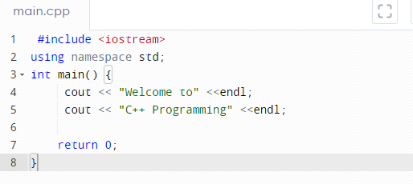

**Output :**

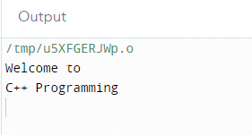

**Task 2:** Write a C++ program that prints following shapes/patterns using cout statement:

(1) (2) (3) (4) (5) (6)

* ********** * * ***** *****

*** * * ** ** **** ****

***** * * *** *** *** ***

*** * * **** **** ** **

* ********** ***** ***** * *

Input and Output of (a):

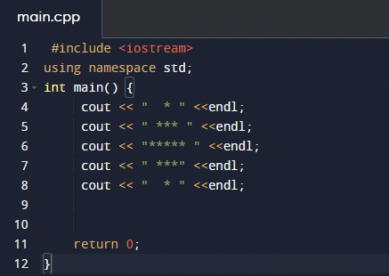

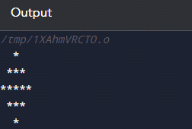

Input and Output of (b):

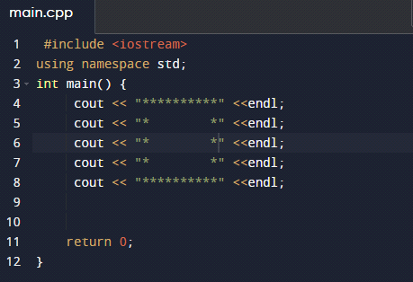

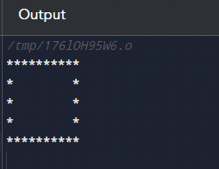

Input and Output of (c):

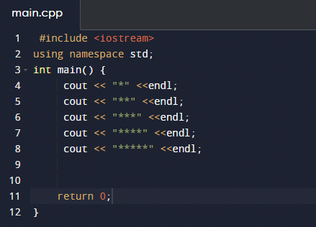

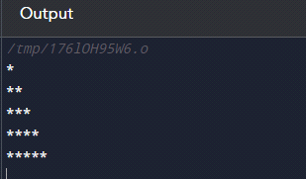

Input and Output of (d):

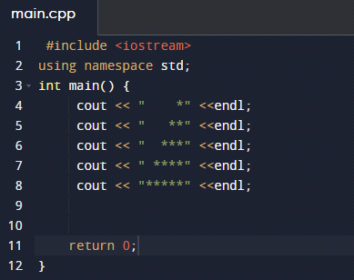

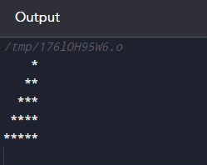

Input and Output of (e):

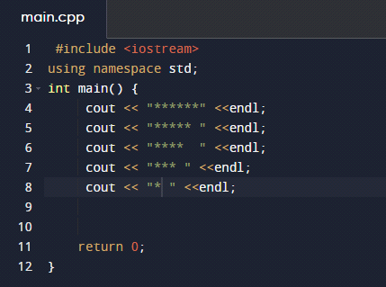

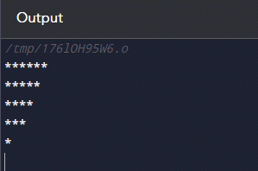

Input and Output of (f):

